**Nodejs study from 15Dec2025 08:00 PM**

<https://youtu.be/zb3Qk8SG5Ms?si=2APVCjhxtbDPYPyn>

git repo:

[iamshaunjp/node-crash-course: Course files for the Node.js Crash Course tutorial series on The Net Ninja YouTube channel.](https://github.com/iamshaunjp/node-crash-course)

<https://github.com/iamshaunjp/node-crash-course>

lesion 2:

<https://youtu.be/OIBIXYLJjsI?si=8FKcmk3vKN_dkNio>

st 10:00

stop : 15Dec2025 1024 PM ( 35M)

st: 23:11

stop : 16Dec2025 0650 AM ( 70Mhttps://crs.istreamed.net/?k=23d64256-7eb9-4ea5-8b5c-f4a5cef99963

chrome://settings/searchEngines

default-search

**Node.js Crash Course Tutorial #3 - Clients & Servers**

Next:

<https://youtu.be/-HPZ1leCV8k?si=XYy7hrhN1x0XHKgy>

<https://youtu.be/DQD00NAUPNk?si=wrdzmpglzX_qiVHP>

st: 14:50 (65M)

**Node.js Crash Course Tutorial #5 - NPM**

<https://youtu.be/bdHE2wHT-gQ?si=dh1xaz939NOdSIZr>

<http://npmjs.com/>

loadmon – live reload server

st 5:00

|  |
| --- |
| **Lodash** is a popular **JavaScript utility library** that you install using **npm**, and it helps you write **cleaner, shorter, and more reliable JavaScript code**. |

**Node.js Crash Course Tutorial #6 - Express Apps**

<https://youtu.be/Lr9WUkeYSA8?si=JvkpB89W55izaJv6>

|  |
| --- |
| **Express** is a **Node.js web framework** installed via **npm**, and it is mainly used to **build backend APIs and web servers easily and quickly**.  Think of it as a **lightweight layer on top of Node.js** that simplifies handling HTTP requests. |

<https://youtu.be/Lr9WUkeYSA8?si=tPW-QSkLH9FsCBvg>

St : 13.11

Stop ( 20-12-2025, 07:30 PM ) (90M)

07:30 – 08:00 –exercise & breakfast.

08:00 AM – 09:00 Am -sleep

09-12 🡺 relax, tea, phone call with ppalayam & erode

12-3 – eashwash, library,

3- 7 – luch & sleep

7-12 – relax , went to Vicky home,..wentot hash tag for te

12AM- 2:30 AM 🡺 funcks call

02:30 Am – 03:00 🡺 reels

03:00 Am to 05:03 AM ( 60M+40M = 100M) study

21-12-2025 , 03:00 Am started

**Node.js Crash Course Tutorial #7 - View Engines**

<https://youtu.be/yXEesONd_54?si=YP1GZ3XGGkcQD4CN>

[EJS -- Embedded JavaScript templates](https://ejs.co/)

<https://ejs.co>

 EJS is a simple templating language that lets you generate HTML markup with plain JavaScript

St : 07:34

St : 12:41

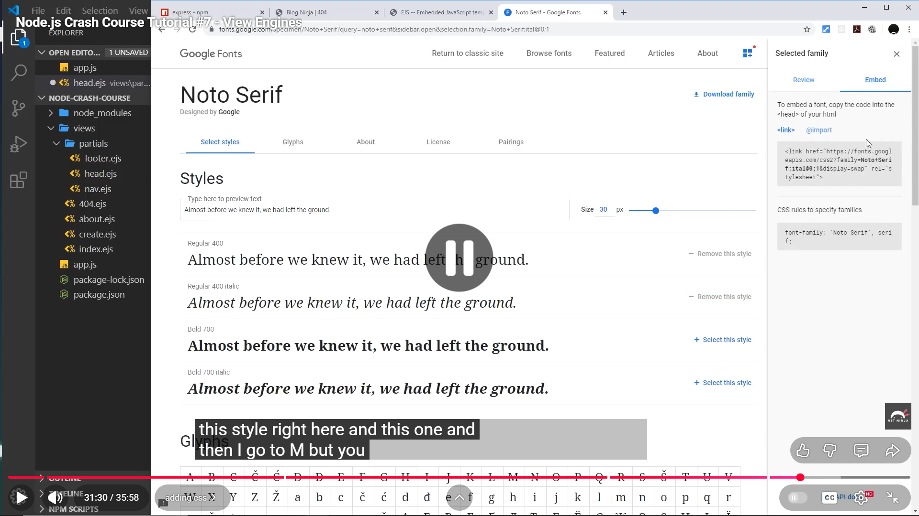

<https://youtu.be/_GJKAs7A0_4?si=ivUZAVvrFRepTGrp>

**Node.js Crash Course Tutorial #8 - Middleware**

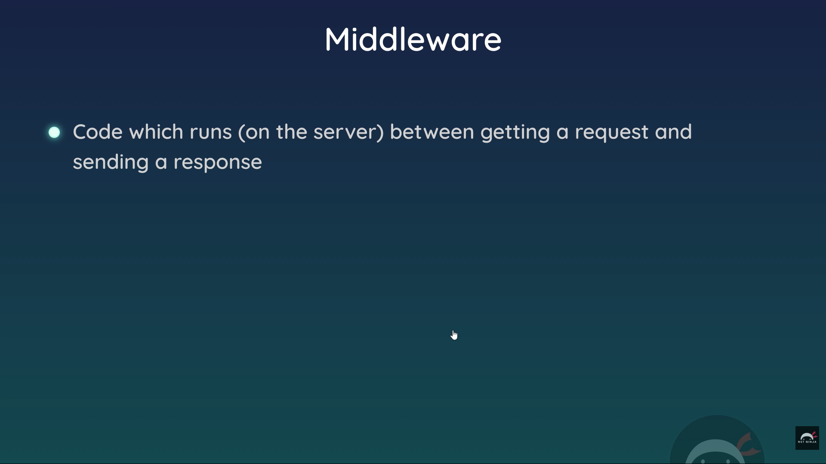

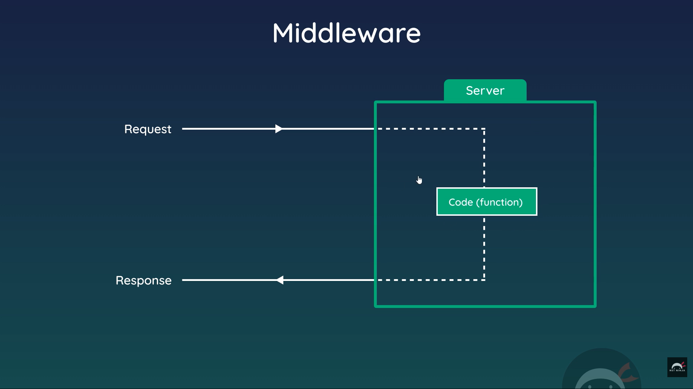

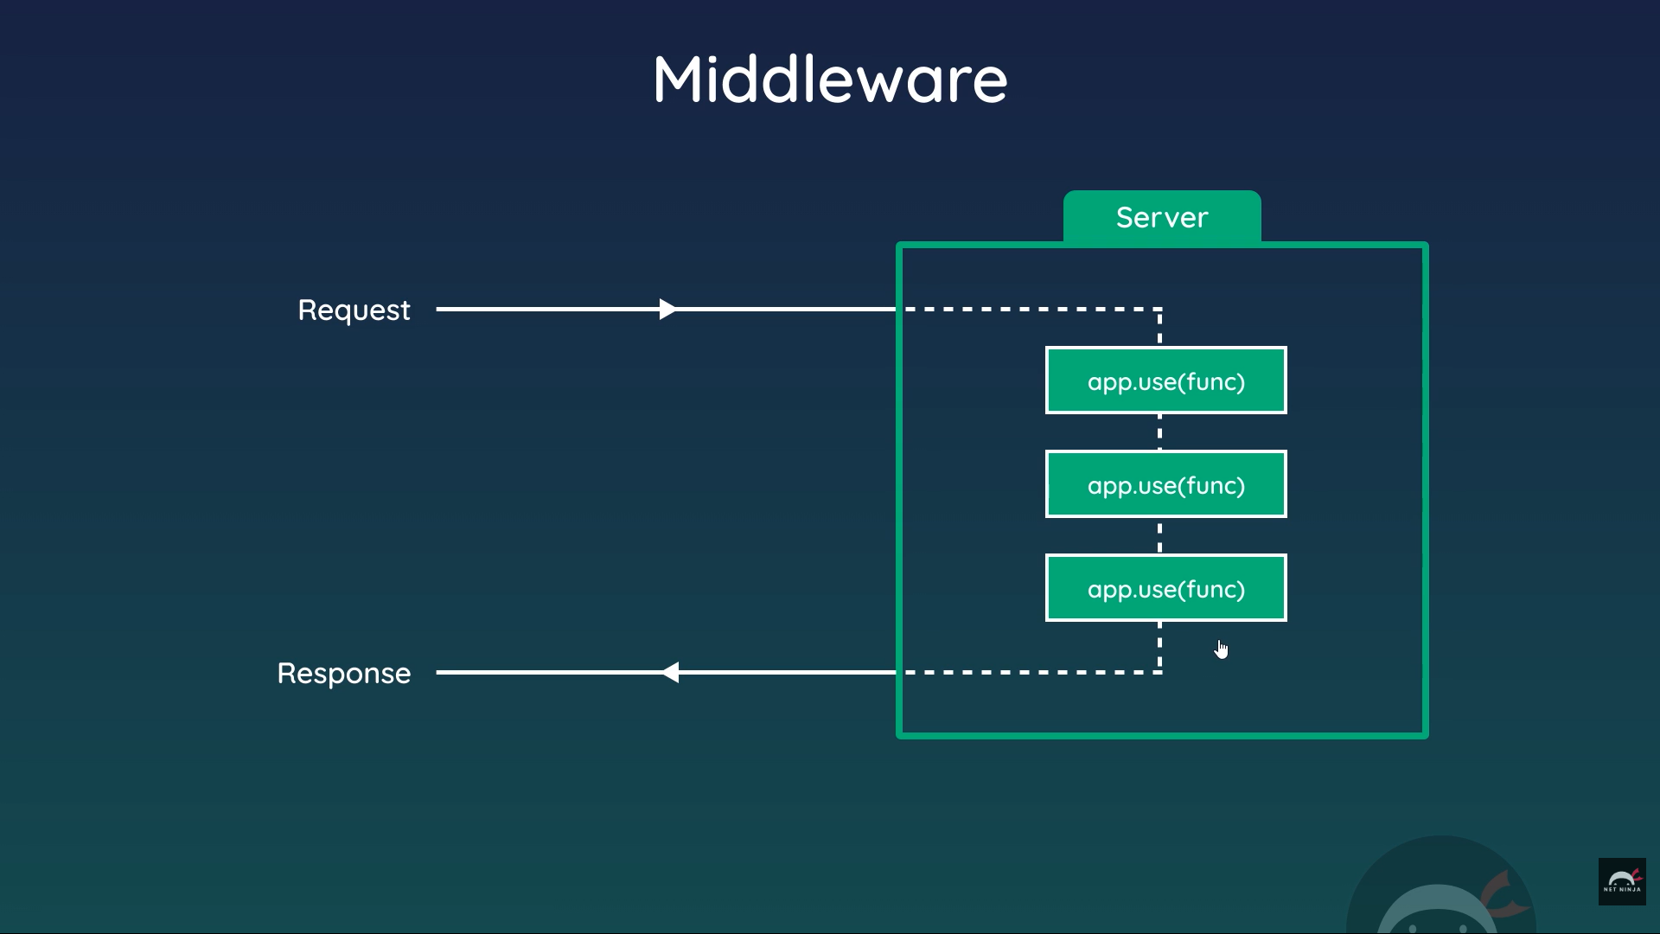

I started but nees to start from beginning

<https://youtu.be/_GJKAs7A0_4?si=C_Zb_nIXdnZ7MEV5>

stop : 22-12-2025(0715AM)

(85M)

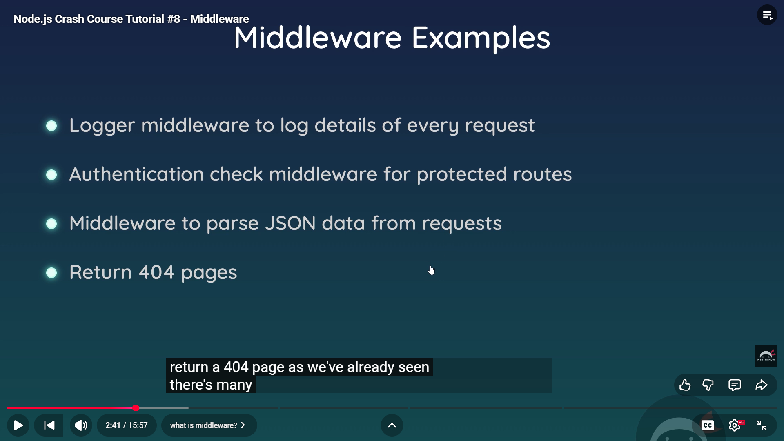

Start : 23Dec2025 06:00 AM

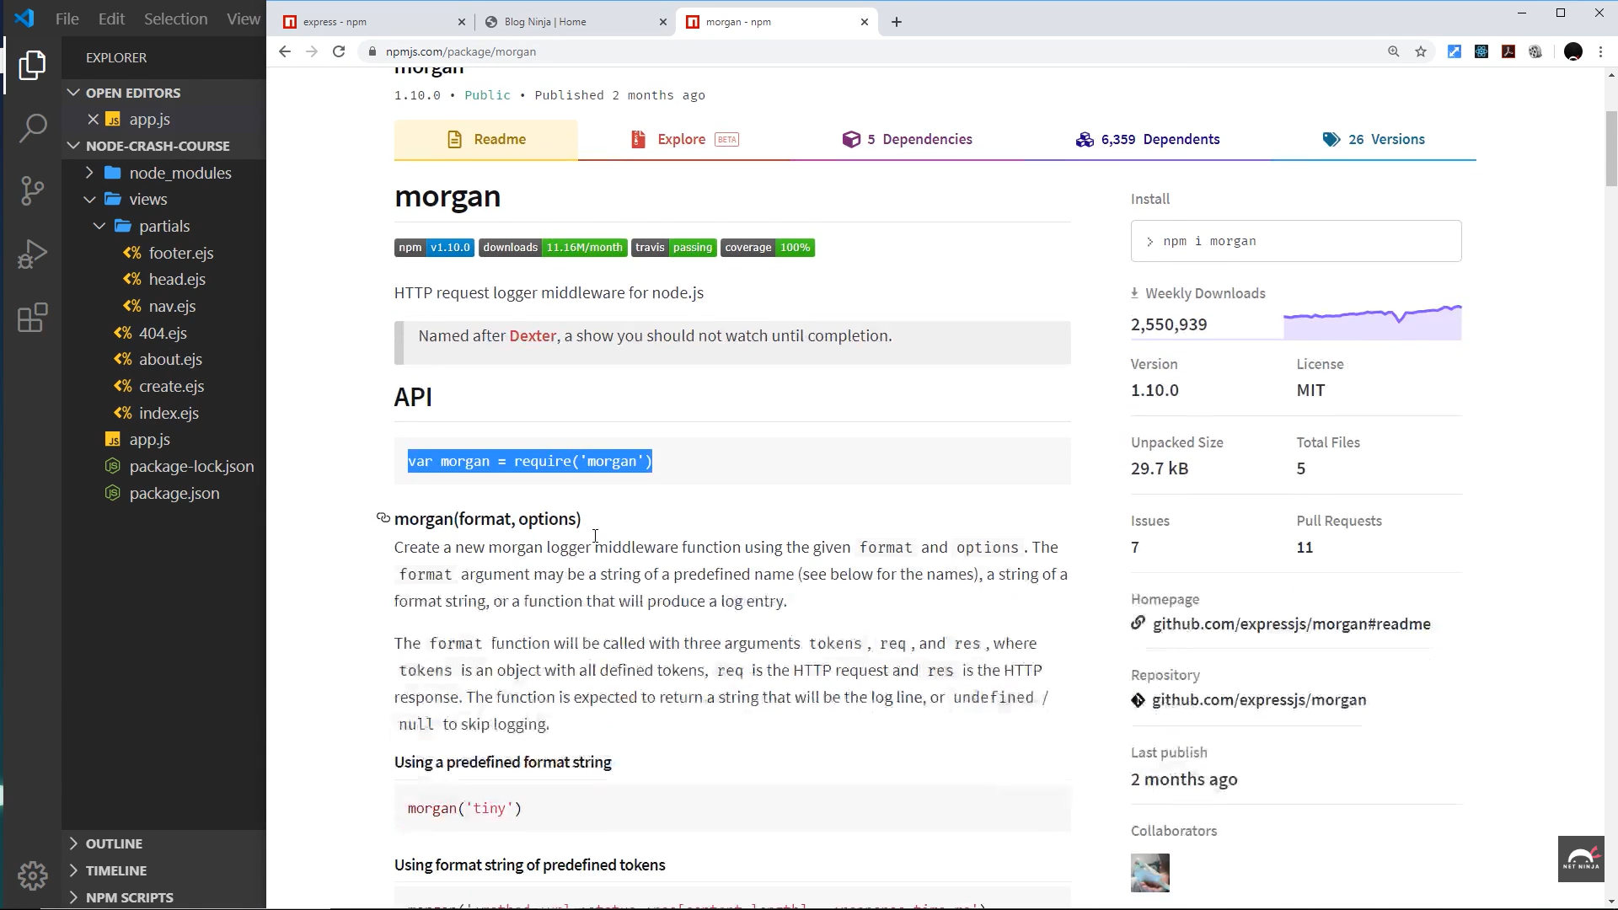

<https://youtu.be/bxsemcrY4gQ?si=az0FlOwnZT0kyakj>

**Node.js Crash Course Tutorial #9 - MongoDB**

mongodb.com/cloud/atlas

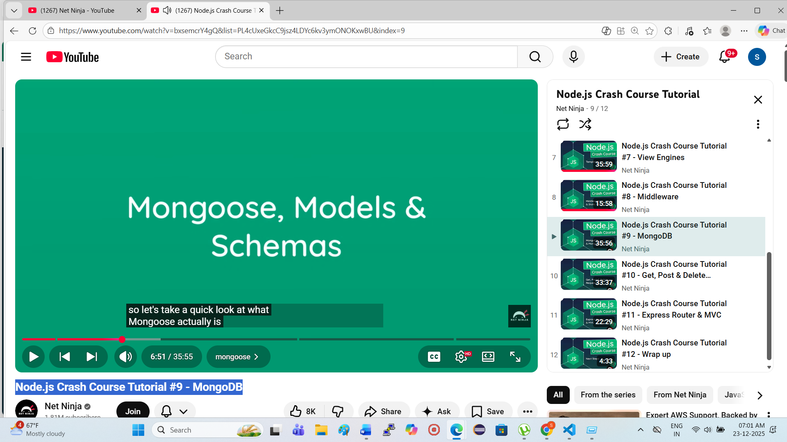

Stop : 07:00 AM 23-12-2025

St: 06:51

Note : Next u will start from 0651, then revise u will do the practical

Start: 24-12-2025 ,0550 AM

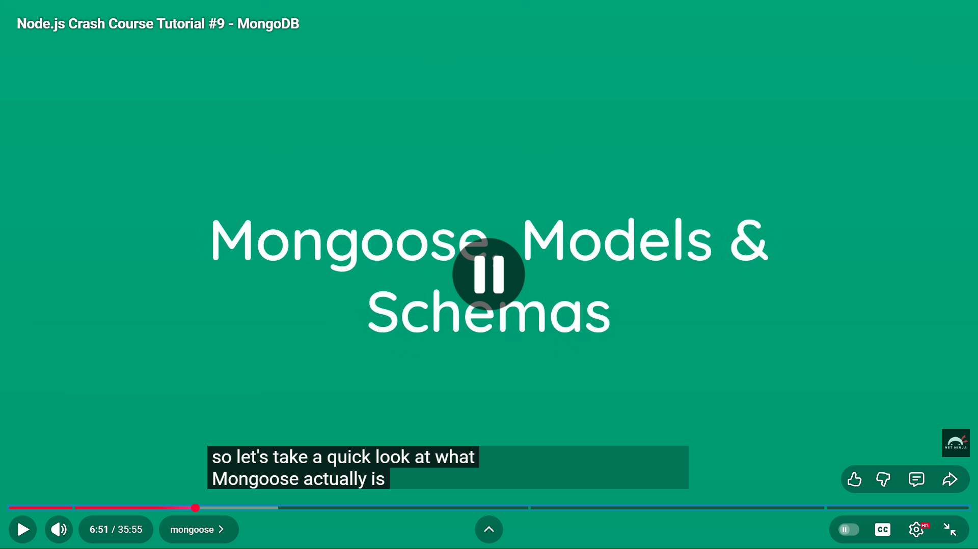

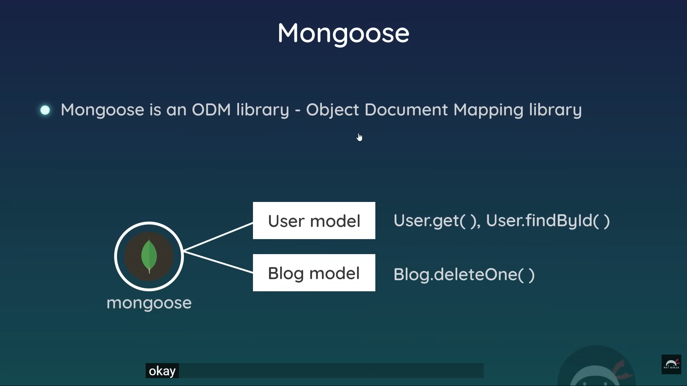

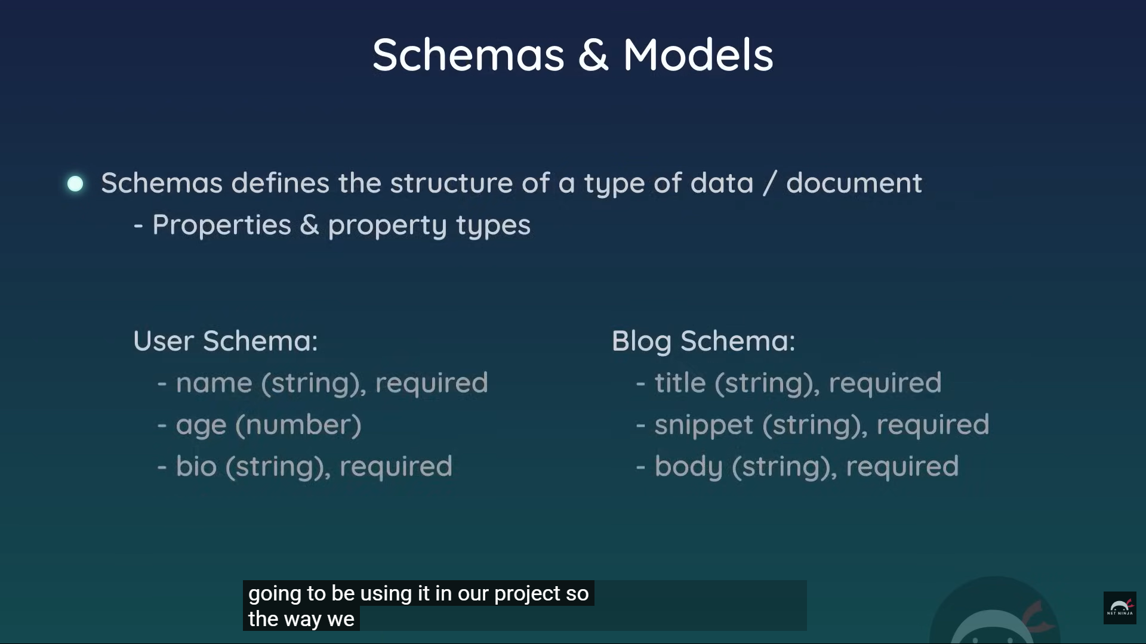

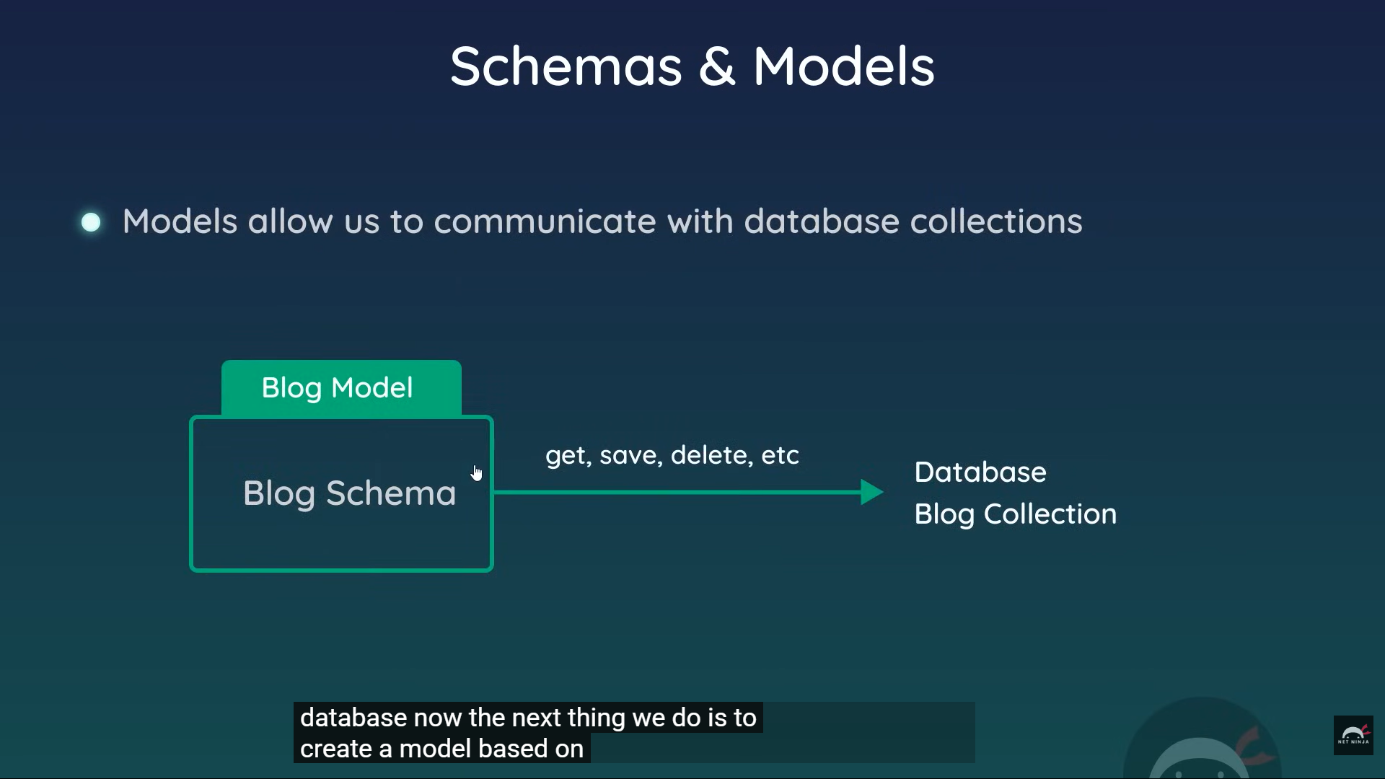

**Done at 0650 AM (60M)**

**Need to start revision**

**Starts : 25-12-2025, 05:16 AM**

mongodb.com/cloud/atlas

mongodb.com/cloud/atlas

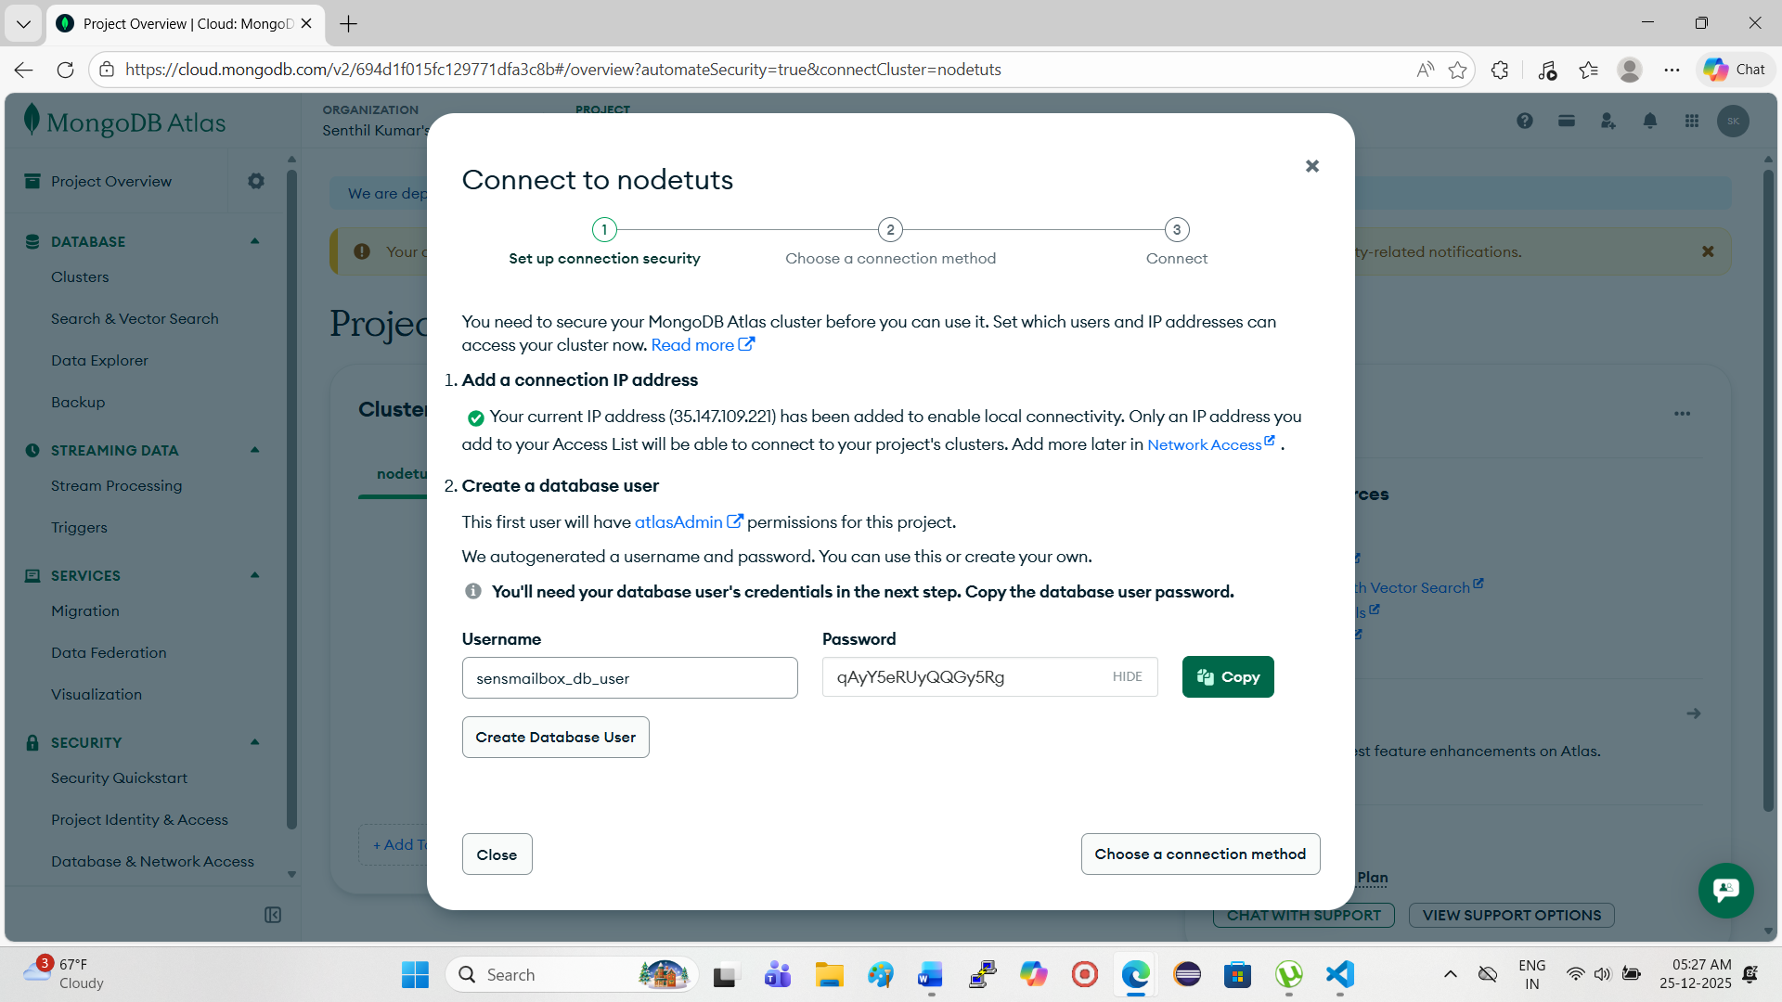

**mongodb+srv://netninja:<db_password>@nodetuts.tlmakya.mongodb.net/?appName=nodetuts**

**st : 20;36**

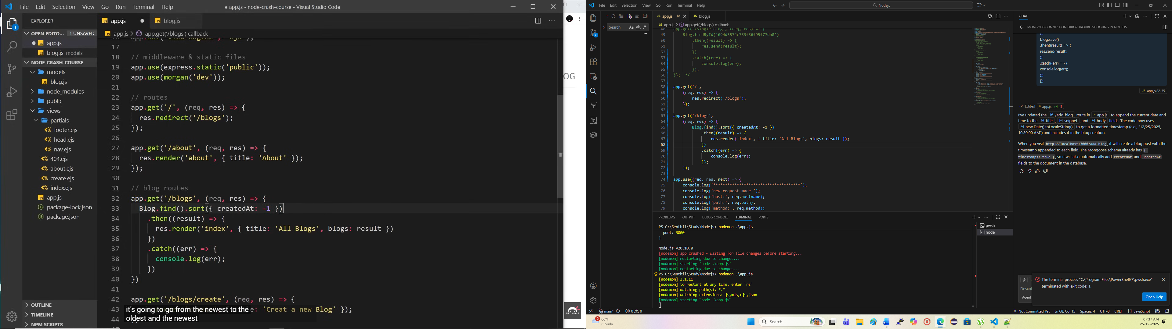

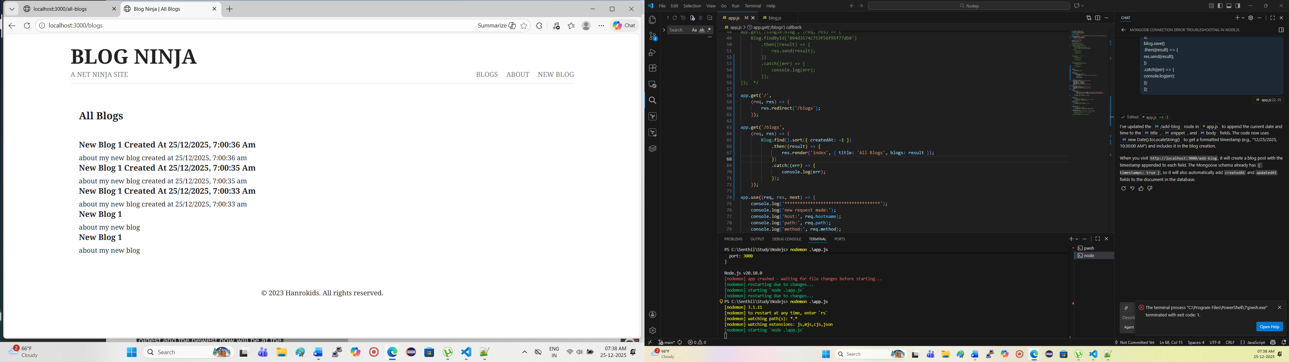

**Lab exercise done. Got all the expected output . stops at 07:39 AM, 25-12-2025**

**Next:**

[**https://youtu.be/VVGgacjzc2Y?si=WiYjSP6NWf-SkR0M**](https://youtu.be/VVGgacjzc2Y?si=WiYjSP6NWf-SkR0M)

**Node.js Crash Course Tutorial #10 - Get, Post & Delete Requests**

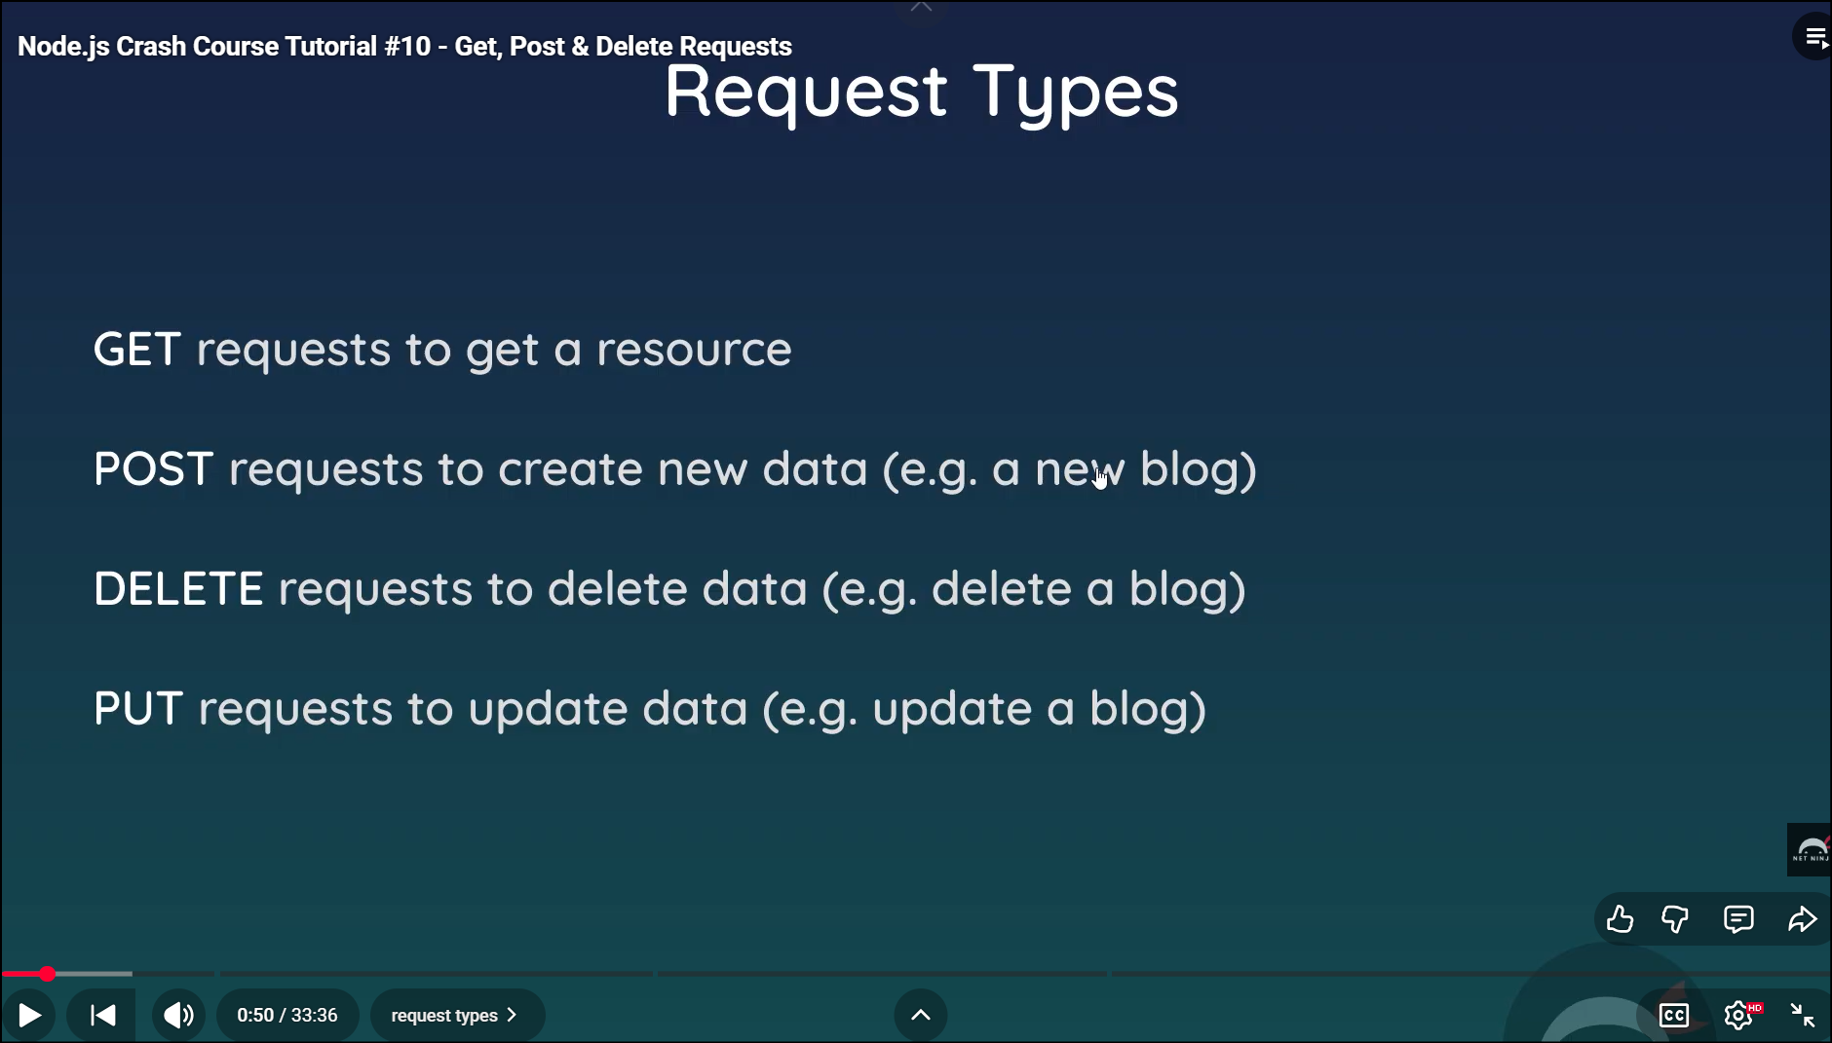

**St : 1:45**

**NOT start asusual..complete 1st theory**

**Then do practical**

**Todays study was interetin**

**Woke up 3 AM for jk airport drop off**

**Return home at 5 PM**

**05:15 AM – 05:35 AM - (20M) – 05:35 -0540 (break , fashwash, hot water drink.) ( put water fisrt then do face wash then drink water and continue the study**

**05:40 AM – 06:00 AM - (20M) – 06:00 – 06:05 (BREAK)**

**06:05 AM – 06:25 AM - (20M) – 06:25 – 06:30 (BREAK)**

**06:05 AM – 06:25 AM - (20M) – 06:25 – 06:45 (BREAK)**

**--TO BE CONINUED..FEEELNG SLEEPY**

**Node.js Crash Course Tutorial #10 - Get, Post & Delete Requests**

[**https://youtu.be/VVGgacjzc2Y?si=8APNhSBi4hZwHu87**](https://youtu.be/VVGgacjzc2Y?si=8APNhSBi4hZwHu87)

**start: 26-Dec-25, 0525AM**

**st:20:17**

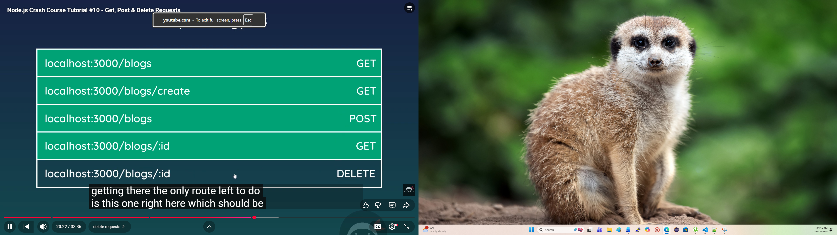

**Done > needs to do practical**

**Idea :**

**Create a simple springboot ‘helloworld’ project kept in local**

**Open the exsiting office project**

**Attach it copilot and start to analysis on this**

**Then ask copilot to convert your helloword project as like your attached prokect..then u get to know**

**What is the architecture of this project**

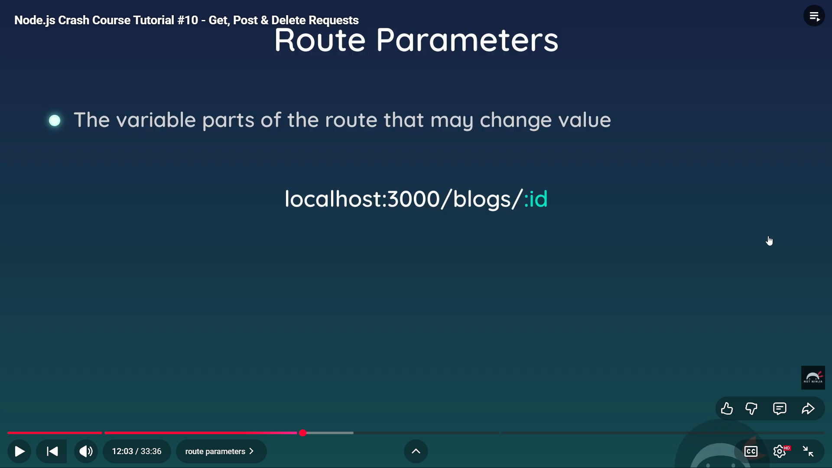

**05:25 – 0545 (20)**

**05:55 – 06:15 (20)**

**06:20-06:50 (30M)**

**Total : 80M**

**St : 12:13 c=continue the practical session no need to start from beginning**

[**https://youtu.be/VVGgacjzc2Y?si=Upb_YNC3uPU4V-gy**](https://youtu.be/VVGgacjzc2Y?si=Upb_YNC3uPU4V-gy)

**Node.js Crash Course Tutorial #10 - Get, Post & Delete Requests**

**Starts at : 30-12-2025, 05:48 AM**

**🡺done @ 30-12-2025 ,07:03 AM ( 75M)**

**Next one:**

**Node.js Crash Course Tutorial #11 - Express Router & MVC**

[**https://youtu.be/zW_tZR0Ir3Q?si=9OSsK-0a72t_zMBn**](https://youtu.be/zW_tZR0Ir3Q?si=9OSsK-0a72t_zMBn)

**start : 03-Jan-2026 05:45 AM**

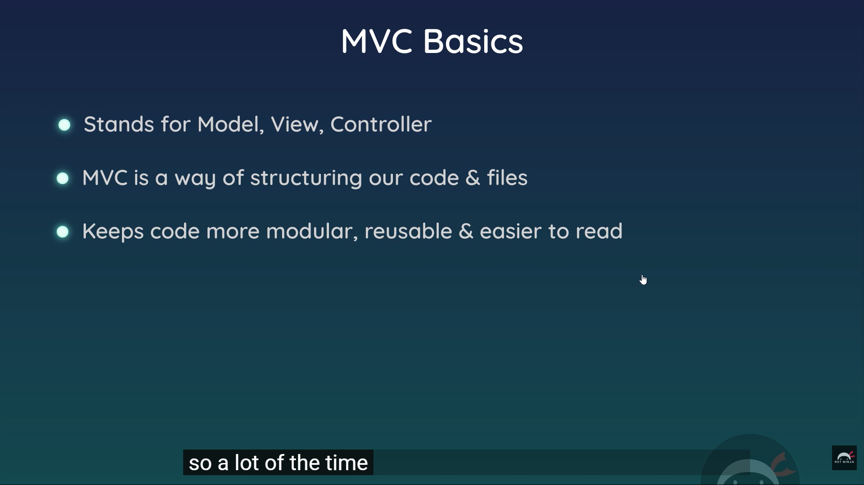

**Theory done: need to do practical**

**Practical done @ 03-jan-2026 0711AM**

**Node.js Crash Course Tutorial #12 - Wrap up**

[**https://youtu.be/nYAyhRAV87A?si=04yAc5_DnB6_233R**](https://youtu.be/nYAyhRAV87A?si=04yAc5_DnB6_233R)

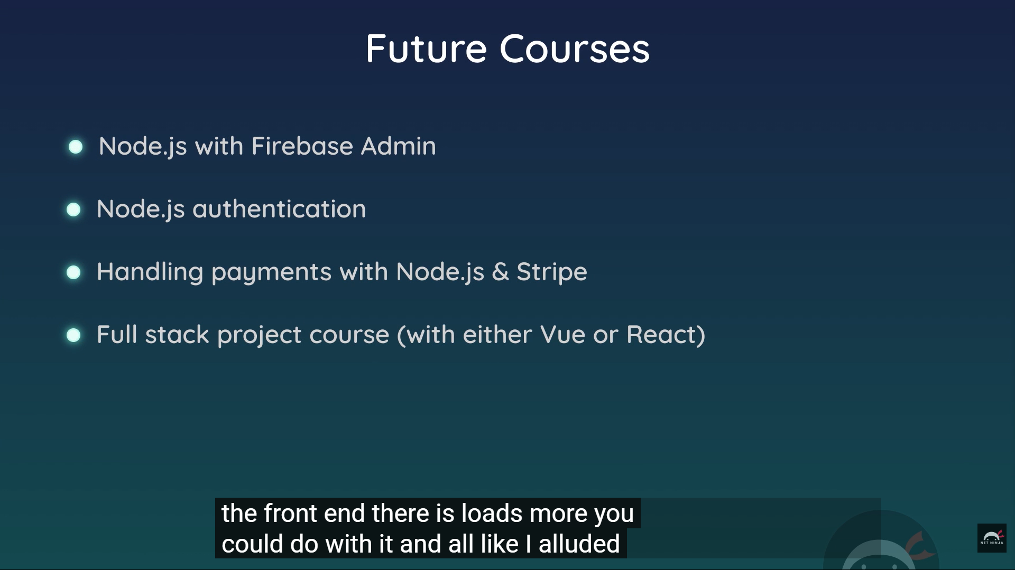

**Done: 03Jan2026 ,0623AM**

**Practical done @ 03-Jan-2026 , 0722 AM**

**Playlist done @@ 03-Jan-2026 , 0722 AM (90M)**

**Greate work.if time permist check chat gpt with each module notes and understto0d overall concepts about node.js**

|  |
| --- |
| **Based on the Node.js project you've attached (a blog application using Express, MongoDB, and EJS) and the YouTube playlist you mentioned (which appears to be "The Net Ninja" Node.js tutorial series), I'll provide a concise analysis of the core Node.js basics you seem to have understood. This is inferred from the code structure, files, and concepts implemented in your project. I'll break it down by key areas, highlighting what's evident and suggesting how to refresh or deepen each one. This isn't exhaustive but focuses on fundamentals—Node.js is vast, so this is a solid foundation.**  **1. Node.js Core Fundamentals**   * **Modules and Require/Exports: You understand how to modularize code using require() to import modules (e.g., const express = require('express')) and module.exports to export objects/functions (e.g., in**[**people.js**](vscode-file://vscode-app/c:/Users/Senthilkumar/AppData/Local/Programs/Microsoft%20VS%20Code/resources/app/out/vs/code/electron-browser/workbench/workbench.html)**exporting an object with arrays). This is shown in files like**[**module.js**](vscode-file://vscode-app/c:/Users/Senthilkumar/AppData/Local/Programs/Microsoft%20VS%20Code/resources/app/out/vs/code/electron-browser/workbench/workbench.html)**,**[**app.js**](vscode-file://vscode-app/c:/Users/Senthilkumar/AppData/Local/Programs/Microsoft%20VS%20Code/resources/app/out/vs/code/electron-browser/workbench/workbench.html)**, and**[**people.js**](vscode-file://vscode-app/c:/Users/Senthilkumar/AppData/Local/Programs/Microsoft%20VS%20Code/resources/app/out/vs/code/electron-browser/workbench/workbench.html)**.** * **Global Objects and Environment: Familiar with globals like __dirname, __filename, and console. Timers (e.g., setTimeout, setInterval) are used in**[**test.js**](vscode-file://vscode-app/c:/Users/Senthilkumar/AppData/Local/Programs/Microsoft%20VS%20Code/resources/app/out/vs/code/electron-browser/workbench/workbench.html)**.** * **Event Loop and Asynchronous Programming: Basics of async with callbacks (e.g., in**[**file.js**](vscode-file://vscode-app/c:/Users/Senthilkumar/AppData/Local/Programs/Microsoft%20VS%20Code/resources/app/out/vs/code/electron-browser/workbench/workbench.html)**for file operations). You handle promises in MongoDB operations (e.g., .then() and .catch() in**[**app.js**](vscode-file://vscode-app/c:/Users/Senthilkumar/AppData/Local/Programs/Microsoft%20VS%20Code/resources/app/out/vs/code/electron-browser/workbench/workbench.html)**).** * **Refresh Tip: Revisit the event loop with simple examples (e.g., blocking vs. non-blocking I/O). Run node test.js to see timers in action.**   **2. File System (fs Module)**   * **Reading/Writing Files: You can read files synchronously/asynchronously (e.g., fs.readFile in**[**file.js**](vscode-file://vscode-app/c:/Users/Senthilkumar/AppData/Local/Programs/Microsoft%20VS%20Code/resources/app/out/vs/code/electron-browser/workbench/workbench.html)**), write files (e.g., fs.writeFile), and handle directories (e.g., fs.mkdir, fs.rmdir).** * **Streams: Basic understanding of readable/writable streams for efficient file handling (e.g., in**[**streams.js**](vscode-file://vscode-app/c:/Users/Senthilkumar/AppData/Local/Programs/Microsoft%20VS%20Code/resources/app/out/vs/code/electron-browser/workbench/workbench.html)**using createReadStream and pipe).** * **Refresh Tip: Experiment with piping streams between files or to HTTP responses. Check**[**streams.js**](vscode-file://vscode-app/c:/Users/Senthilkumar/AppData/Local/Programs/Microsoft%20VS%20Code/resources/app/out/vs/code/electron-browser/workbench/workbench.html)**output by running it.**   **3. HTTP Server and Networking**   * **Creating a Basic Server: You built a simple HTTP server with http.createServer (e.g., in**[**server.js**](vscode-file://vscode-app/c:/Users/Senthilkumar/AppData/Local/Programs/Microsoft%20VS%20Code/resources/app/out/vs/code/electron-browser/workbench/workbench.html)**), handling requests, responses, and routing based on URLs.** * **Request/Response Handling: Setting headers, status codes, and serving static content (e.g., HTML files).** * **Refresh Tip: Compare**[**server.js**](vscode-file://vscode-app/c:/Users/Senthilkumar/AppData/Local/Programs/Microsoft%20VS%20Code/resources/app/out/vs/code/electron-browser/workbench/workbench.html)**(vanilla HTTP) with**[**app.js**](vscode-file://vscode-app/c:/Users/Senthilkumar/AppData/Local/Programs/Microsoft%20VS%20Code/resources/app/out/vs/code/electron-browser/workbench/workbench.html)**(Express). Test with node server.js and hit routes in a browser.**   **4. Express Framework**   * **App Setup and Routing: Setting up an Express app, defining routes (e.g., app.get('/')), and handling middleware (e.g., static files with app.use(express.static('public'))).** * **Middleware: Custom middleware for logging requests (e.g., in app copy.js), and parsing URL-encoded data (e.g., express.urlencoded in**[**app.js**](vscode-file://vscode-app/c:/Users/Senthilkumar/AppData/Local/Programs/Microsoft%20VS%20Code/resources/app/out/vs/code/electron-browser/workbench/workbench.html)**).** * **View Engines and Templating: Using EJS for rendering views (e.g., app.set('view engine', 'ejs')), passing data to templates (e.g., rendering index.ejs with blog data).** * **Static Files and Serving: Serving CSS/JS from**[**public**](vscode-file://vscode-app/c:/Users/Senthilkumar/AppData/Local/Programs/Microsoft%20VS%20Code/resources/app/out/vs/code/electron-browser/workbench/workbench.html)**folder.** * **Refresh Tip: Review middleware order in**[**app.js**](vscode-file://vscode-app/c:/Users/Senthilkumar/AppData/Local/Programs/Microsoft%20VS%20Code/resources/app/out/vs/code/electron-browser/workbench/workbench.html)**. Add a new route and template to see EJS in action.**   **5. Databases and Data Persistence**   * **MongoDB with Mongoose: Connecting to a MongoDB Atlas cluster (e.g., in**[**app.js**](vscode-file://vscode-app/c:/Users/Senthilkumar/AppData/Local/Programs/Microsoft%20VS%20Code/resources/app/out/vs/code/electron-browser/workbench/workbench.html)**), defining schemas/models (e.g., Blog in**[**blog.js**](vscode-file://vscode-app/c:/Users/Senthilkumar/AppData/Local/Programs/Microsoft%20VS%20Code/resources/app/out/vs/code/electron-browser/workbench/workbench.html)**), and performing CRUD operations (e.g., save(), find(), findById()).** * **Schema Definition: Creating models with fields like title, snippet, body.** * **Refresh Tip: Query your database manually (e.g., via MongoDB Compass) and compare with routes in**[**blogRoutes.js**](vscode-file://vscode-app/c:/Users/Senthilkumar/AppData/Local/Programs/Microsoft%20VS%20Code/resources/app/out/vs/code/electron-browser/workbench/workbench.html)**and**[**blogControllers.js**](vscode-file://vscode-app/c:/Users/Senthilkumar/AppData/Local/Programs/Microsoft%20VS%20Code/resources/app/out/vs/code/electron-browser/workbench/workbench.html)**.**   **6. Project Structure and Best Practices**   * **MVC Pattern: Separating concerns with models, views, controllers, and routes (e.g.,**[**models**](vscode-file://vscode-app/c:/Users/Senthilkumar/AppData/Local/Programs/Microsoft%20VS%20Code/resources/app/out/vs/code/electron-browser/workbench/workbench.html)**,**[**controllers**](vscode-file://vscode-app/c:/Users/Senthilkumar/AppData/Local/Programs/Microsoft%20VS%20Code/resources/app/out/vs/code/electron-browser/workbench/workbench.html)**,**[**routes**](vscode-file://vscode-app/c:/Users/Senthilkumar/AppData/Local/Programs/Microsoft%20VS%20Code/resources/app/out/vs/code/electron-browser/workbench/workbench.html)**,**[**myviews**](vscode-file://vscode-app/c:/Users/Senthilkumar/AppData/Local/Programs/Microsoft%20VS%20Code/resources/app/out/vs/code/electron-browser/workbench/workbench.html)**).** * **Package Management: Using**[**package.json**](vscode-file://vscode-app/c:/Users/Senthilkumar/AppData/Local/Programs/Microsoft%20VS%20Code/resources/app/out/vs/code/electron-browser/workbench/workbench.html)**for dependencies (e.g., Express, Mongoose, EJS) and scripts (e.g., npm start).** * **Error Handling: Basic try/catch in async operations.** * **Refresh Tip: Run npm install to reinstall deps, then node app.js or use**[**start-app.ps1**](vscode-file://vscode-app/c:/Users/Senthilkumar/AppData/Local/Programs/Microsoft%20VS%20Code/resources/app/out/vs/code/electron-browser/workbench/workbench.html)**to start the app. Check for errors with get_errors if needed.**   **Overall Assessment**  **You've covered the essentials of Node.js for building a full-stack web app: server-side logic, routing, databases, and templating. The playlist likely walked you through these step-by-step, and your project applies them practically. Strengths include integrating Express with MongoDB and EJS—common for blog-like apps. Areas to watch: Deeper async patterns (e.g., async/await instead of promises), security (e.g., input validation), and deployment (e.g., environment variables for DB URLs).**  **To refresh, rerun the app (node app.js), test routes (e.g., /blogs/create), and review the playlist videos alongside your code. If you want to build on this (e.g., add authentication or APIs), let me know! If you need help with specific code or running tests, provide more details.** |